Unit 9. Have you ever been to a museum?
Period3 SectionB1a-1d
【教学目标】
知识与技能
（1）熟练掌握下列词汇：
hear, try, see, visit，couple, German, theme, ride, province
（2）熟练掌握下列短语：
the Terracotta Army, the Great Wall, the Bird’s Nest, the Palace Museum，a couple of, so many, with a special theme
（3）掌握下列句型：
Have you ever heard of …?
Have you been to another province in China?
Have you visited …?
Have you seen …?
Have you tried …?
When did you start studying English?
How long have you been studying English?
过程与方法
听力练习，小组问答练习
情感、态度与价值观
培养学生爱祖国，爱生活，以祖国为骄傲的情感。
【教学重难点】
重点：
1．谈论过去的经历
2. 能够熟练运用现在完成时态
难点：
现在完成时态的正确使用及动词的过去分词的正确表达
【导学过程】
一．新课预习
通过预习会读这些景点名称，熟读1b的句子并且理解。
二. 情景导入
T: Have you ever been to …?
Show the pictures of the four interesting places in China and have Ss match each picture with the correct name.
导入景点名称the Terracotta Army，the Great Wall，the Bird’s Nest，the Palace Museum，通过图片让学生学习景点的英文表达。
了解景点名称，为后面的听力扫除障碍。
三．合作探究
1.Work on 1b & 1c)
(1)T: A student is interviewing a foreign student who has been to China. Please listen and check the questions you hear.(1b)
(2)T: Listen again and take notes. (1c)
Have Ss read the headings given in the note sheet and ask them to predict what kind of information they should put in for each heading.
第一遍听力，帮助学生进一步学习巩固学习现在完成时的一般疑问句，第二遍听力，让学生在听力中听出一些关键信息。
2. Post-listening (Work on 1d: Pair work)
T: Work in pairs. Imagine one of you is the foreign student who visited China and one of you is the interviewer.
Have Ss prepare some questions before they conduct their interview.
3. Review (Exercise)
Have Ss write the sentences/questions in English to review the sentences they have learned in this lesson.
四．点拨总结
.一般过去时，现在完成进行时和现在完成时的区别
一般过去时只表示_______________，和___________不发生联系。现在完成时是用_____________说明现在的情况。
He lived in Beijing in 2000. 只说明他2000年住在北京，他目前住在哪里并不清楚。
He has lived in Beijing since 2000. 说明他自从2000年就住在北京，他目前还住在北京。
现在完成时和现在完成进行时都可以表示“从过去开始一直持续到现在”这一概念，有时两者可以互相代用，但前者多用于口语。在含义上如着重表示动作的结果时，多用_______________ 时；如着重表示动作一直在进行，即动作的延续性或者动作仍然继续下去时，则多用____________________________时。如：
a. I have written six letters since breakfast. 从吃早饭到现在我写了六封信。
I have been writing letters since breakfast. 从吃早饭到现在我一直在写信。
b. I have read this book. 我读过这本书。
I have been reading this book. 我一直在读这本书。
五．训练评价
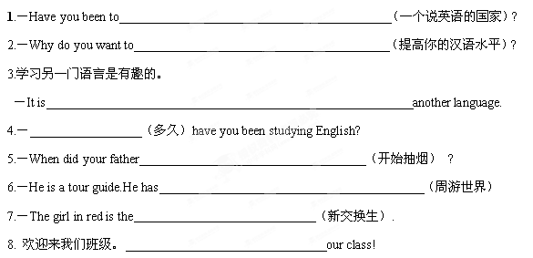
根据情景填入合适的单词补全对话
A: Good morning. Are you Li Ming, the new ________ students?
B: Yes , I am.
A: _________ to my class. I need to ask you some questions.
How_______ have you been studying English?
B: For three years.
A: ________ do you learn English?
B: Because I want to travel _______ over the world.
A: Have you ever been to _______ English---speaking country?
B: Yes , I have.
A: Good luck with your study.

六．学习反思
开心 ，我学会了：
1.
2.
3.
加油 ，这些我还不懂：
1.
2.
3.

